**FULLSTACK DEVELOPMENT**

***A Summer Internship Report submitted in partial fulfillment of the***

***requirements for the award of degree of***

**BACHELOR OF TECHNOLOGY**

**In**

**COMPUTER SCIENCE AND ENGINEERING**

## Submitted by:

20A91A0596



**DEPARTMENT OF COMPUTER SCIENCE AND ENGINEERING**

**ADITYA ENGINEERING COLLEGE (A)**

**Approved by AICTE, Permanently affiliated to JNTUK & Accredited by NAAC with ‘A’ Grade**

**Recognized by UGC under the sections 2(f) and 12(B)of the UGC act 1956**

**Nagar, ADB Road –Surampalem 533437, E.G. Dist., A.P.,**

**2022-2023.**

**ADITYA ENGINEERING COLLEGE (A)**

**Approved by AICTE, Permanently Affiliated to JNTUK & Accredited by NAAC with ‘A’ Grade**

**Recognized by UGC under the sections 2(f) and 12(B) of the UGC act 1956**

**Aditya Nagar, ADB Road - Surampalem – 533437, E.G.Dist., A.P.,**

**DEPARTMENT OF COMPUTER SCIENCE AND ENGINEERING**



**CERTIFICATE**

This is to certify that the Internship report entitled *“***FULL STACK***”*is being submitted by

**VEERA HARI SAIKUMAR KOLLI 20A91A0596**

In partial fulfillment of the requirements for award of the B. tech degree in Informational Technology for the academic year 2022-2023.

**InternshipCoordinator Head ofthe Department**

**Signature of the Examiner:**

**DECLARATION**

We hereby declare that the project entitled **“FULL STACK”** is a genuine project. This work has been submitted to the **ADITYA ENGINEERING COLLEGE,** Surampalem,permanently affiliated to **JAWAHARLAL NEHRU TECHNOLOGICAL UNIVERSITY, KAKINADA** in partial fulfillment of the **B. tech**degree**.** We further declare that this project work has not been submitted in full or part of the award of any degree of this or any other educational institutions.

**By**

**K V H SAIKUMAR(20A91A0596)**

**Internship CompletionCertificate**

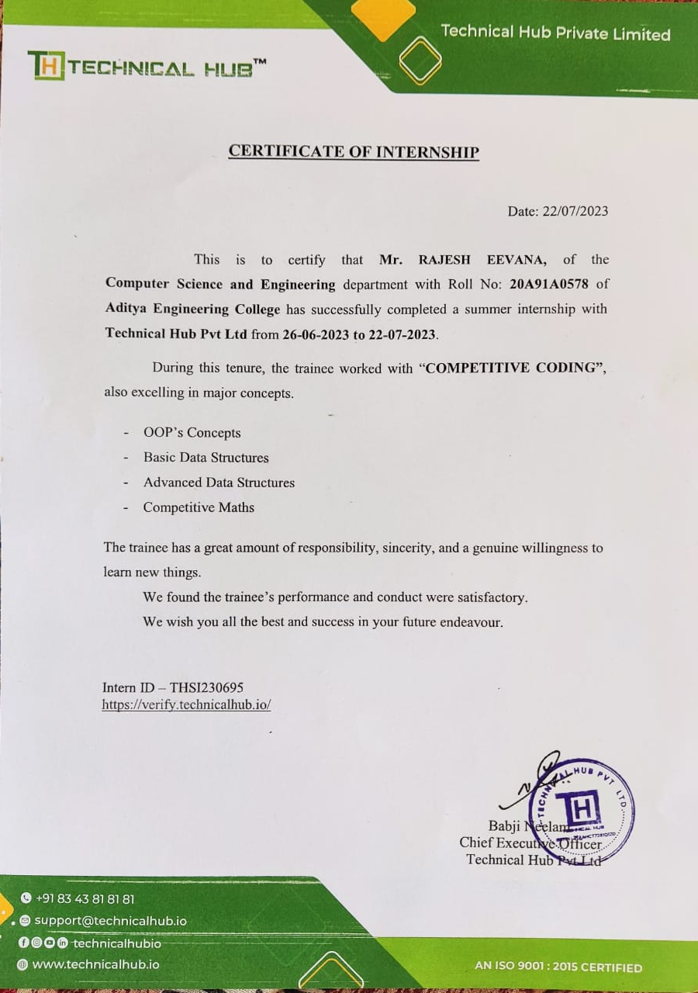

**ACKNOWLEDGEMENT**

First I would like to thank the Director of Technical Hub,Surampalem for giving me the opportunity to do an internship within the organization. I also would like all the people that worked along with me in Technical Hub,Surampalem with their patience and openness they created an enjoyable working environment.

It is with immense pleasure that we would like to express our indebted gratitude to our Internshipcoordinator**N.Durga prasad, Full stack** who has guided us a lot and encouraged us in every step of the intern project work, **his** valuable moral support and guidance throughout the Intern project helped us to a greater extent.

Our deepest thanks to **Dr.M.V.Rajesh,Professor&HOD-IT**for inspiring us all the way and for arranging all the facilities and resources needed for our project.

We wish to thank **Dr. S. Rama Sree, Professor** in CSE and Dean(Academics) for her support and suggestions during our project work.

We owe our sincere gratitude to **Dr. M.Sreenivasa Reddy, Principal**for providing a great support and for giving us the opportunity of doing the project.

We are thankful to our **College Management** for providing all the facilities in time to us for completion of our project.

Not to forget, **Faculty,Lab Technicians, non-teaching staff and our friends** who have directly or indirectly helped and supported us in completing our project in time.

# Abstract

# In this internship, I had studied about AZURE DEVOPS. I chose this internship because it helps to develop dynamic webpages and it is useful for my career in Information technology Industry. Under the guidance of PRASAD NDP sir, SIMHADRI sir I learned various new techniques of building websites from basics to advanced which is the very foundation of big problems solved at various levels at the Industry.By learning Full Stack Web development we had many benefits for businesses, including increased efficiency, improved scalability, faster time to market, and improved customer experience. Due to end-to-end visibility, a full stack developer has a better understanding of how the business should be created. It also facilitates transitioning between frontend and backend as they have the potential to handle the both. During this internship period we improved our skills by developing various webpages and worked on various projects like Restaurant Website, Medico Website, Portfolio Website and many more.I had great experience at Technical Hub for providing this internship.

**Internship Objectives**

* Internships are generally thought of to be reserved for college students looking to gain experience in a particular field. However, a wide array of people can benefit from Full stack Internships in order to receive real world experience and develop their skills.
* An objective for this position should emphasize the skills you already possess in the area and your interest in learning more
* Internshipsareutilizedinanumberofdifferentcareerfields,including architecture, engineering, healthcare, economics, advertising and many more.
* Full stack developers front end and backend development skills, tackling a wide variety of tasks in building and maintaining a digital entity(e.g., app, webpage).The position is predicated upon versatility, innovative thinking, and a blend of technical programming knowledge and high-level client communication.
* Utilizinginternshipsisagreatwaytobuildyourresumeanddevelopskillsthatcan beemphasizedinyourresumeforfuturejobs.WhenyouareapplyingforaTraining Internship, make sure to highlight any special skills or talents that can make you stand apart from the rest of the applicants so that you have an improved chance of landing the position.

# WEEKLY OVERVIEW OF INTERNSHIP ACTIVITIES

|  |
| --- |
| **MONTH-1**  **Week1:(18-07-2022 - 24-07-2022)**  **Week2:(25-07-2022 -31-07-2022)** |

|  |
| --- |
| **MONTH-2**  **Week1:(01-08-2022 - 07-08-2022)**  On this session of period they made us work on the I frame tags . These tags are very much useful in linking the two or more websites into a single website. These tags are used to link the maps and location of the particular pages. Generally a developer using the I frame tags develops a project more effiecient. The purpose of developing a website is nothing about to seek the attention of the public and make it useful.  **Week2:( 08-08-2022 - 14-08-2022)**  In this period of time we learnt about the about the forms and the tables that are used to represent the data in the rows and columns. Generally we use tr tag to represent or to create a row and td tag that represents the columns. Information can be stored in the form of the tables.  We use forms such as any registration pages that are used to register for a particular website and for this we used form tags and input type that might be text or g-mail and represent the tick marks symbuls, mobile number etc..    **Week3:( 15-08-2022 - 21-08-2022)**  These queries are used to represent a block of CSS to be applied to a webpage or the websites more responsive in order to make the webpages more relevant to watch. By default the webpage without media queries is suitable only for the computer desktop but not suitable for other resolutions so we have started developing a project using the media queries.  **Week4:( 22-08-2022 - 31-08-2022)**  After learning the basic things or the items We have started using the techniches of developing the tasks such as an Attendance portal and other Grid systems that are developed in these Internship Training Period. Mean we are used to perform many Activity tasks based on the things that we have learnt. These might be in the form of Choosing the appropriate Answer for the questions. Based on the Tasks and Activities they used Award the marks based on performance. |

|  |
| --- |
| **MONTH-3**  **Week1:( 01-09-2022 - 07-09-2022)**  Topics in the CSS Such as Grid system and the different types of the style sheets such as the Inline styles, Internal styles and External styles have been covered. These are used to develop a html webpage by applying the styles.  CSS is a cornerstone technology of the world wide web, alongside HTML and JavaScript. Many Markup Languages use CSS including the XHTML, plain XML, SVG and XUL.  **Week2:( 08-09-2022 - 14-09-2022)**  Started Working on developing an Application Using the Cascading Style Sheets that makes us to understand how the web pagesmakes us visibility clear and neat**.** Developed a grid system by applying the styles like different font sizes, border styles and margin styles that too applying the background color and the background images. Without proper color combination or the styles the web pages doesn’t makes us the clear visibility.  **Week3:( 15-09-2022 - 21-09-2022)**  working on the Bootstrap that makes us the webpage more responsive. Generally in every desktop resolution webpage looks different in each device so this can be avoided using the Bootstrap 3.  It contains many number of predefined classes in the bootstrap and we have to include bootstrap links into the webpage of the code. This bootstrap was widely used now a days to develop a website for the sake of developing a websites  **Week4:( 22-09-2022 - 30-09-2022)**  Focused on developing the web pages using the bootstrap 3. Using the Html, CSS and Bootstrap we built a Capstone project Regarding the Driving Website that tells us to register to become a certified Car driver by Traffic System. We can also use the media queries behalf of the Bootstrap. But it is a lengthy process to build a website using the @Media queries. |

|  |
| --- |
| **MONTH-4**  **Week1:( 01-10-2022 - 07-10-2022)**  **Week2: ( 08-10-2022 - 14-10-2022)**  **Week3: ( 15-10-2022 - 21-10-2022)**  **Week4: ( 22-10-2022 - 31-10-2022)** |

# WEEKLY OVERVIEW OF INTERNSHIP ACTIVITIES

|  |
| --- |
| **MONTH-5**  **Week1:( 01-11-2022 - 07-11-2022)**  **Week2: ( 08-11-2022 - 17-11-2022)**  On the final Session of the Training period We have started many number of assignment tests on the html, Javascript and Bootstrap. Based on the performance and dialy basis of students have graded each. They have conducted several Mock interviews regarding the Technology round and the HR rpound in order test our confidence levels for attending an interview.  We have submitted The Cap Stone Project -2 (Lakshya School Interface) this website is mainly regarding the School database portal only a static website but a little amount usage of the javascript that helps us to create a model and dialogue boxes that helps us providing the functionality of the webpage. The training period came to an end with the Few Words spoken the Babji sir(CEO of T-HUB). They have distributed the internship certificates those who have scored above 70 percent in the overall Training period. Finally We have Thanked our Mentors NDP sir and Simhadri Sir. |

**INDEX**

|  |  |  |  |  |  |
| --- | --- | --- | --- | --- | --- |
| **Sno.** |  | **Contents** | | **Page no** | |
|  |  |  | |  | |
| 1. |  | Introduction about Full Stack | | 10 | |
| 2. |  | Backend Languages | | 11 | |
| 3. |  | Executive Summary | | 12 | |
| 4. |  | About the Company | | 13 | |
| 5. |  | Opportunities | | 14 | |
| 6. |  | Training | 15 | |
| 7. |  | Challenges Faced | | 16 | |
| 8. |  | Sample projects | | 17-18 | |

1. **Introduction**

# Full stack development:

# It refers to the development of both frontend(client side) and backend(server side) portions of web application.

# Full stack web developers have the ability to design complete web applications and websites. They work on the frontend,backend,database and debugging of web applications or websites.

# Front end languages:

# The frontend portion is built by using some languages which are discussed below:

# HTML:

# HTML stands for Hyper Text Markup Language.HTML is the combination of Hypertext and Markup language.Hypertext defines the link between the web pages.The markup language is used to define the text documentation within tag which defines the structure of web pages.

# CSS:

# Cascading Style Sheets,fondly referred to as CSS,is a simply designed language intended to simplify the process of making web pages presentable. It allows you to apply styles to web pages.It enables you to do this independent of the HTML that makes up each web page.

# JavaScript:

# JavaScript is a famous scripting language used to create the magic on the sites to make the site interactive for the user.It is used to enhancing the functionality of a website to running cool games and web-based software.

# BootStrap:

# Bootstrap is a free and open-source tool collection for creating responsive websites and web applications.It is the most popular HTML,CSS, and JavaScript framework for developing responsive,mobile-first websites.

# Backend Languages

# The backend portion is built by using some languages which are discussed below:

# Node.js:

# Node.js is an open-source and cross platform runtime environment built on Chrome’s V8 JavaScript engine for executing JavaScript code outside of a browser.It provides an event-driven,non-blocking(asynchronous) I/O and cross-platform runtime environment for building highly scalable server-side applications using Javascript.

# MongoDB:

# It is most popular NOSQL database, it is an open source document-oriented database. The term ‘‘NoSQL” means ‘non-relational’.It means that MongoDB isn’t based on the table-like relational database structure but provides an altogether different mechanism for storage and retrieval of data. This format of storage is called BSON(similar to JSON format).

# Angular.js:

# It provides built-in directives and user defined directives and it is extend of HTML.

# Express.js:

# It is a framework of Node.js web server functionality to helpful for new features.

The internship program that I have undergone at Thaniya Technology, gave a great opportunity to

improve my skills and knowledge and also helped me to get a clear picture about the job in

industries. Being an intern I was able to gain insight about how an organization is organized and

how it operates and also more importantly what are the challenges the organization faces and

how it is solved. This internship also provided an opportunity for me to get grips with working,

meeting deadlines and working in a team. In addition to acquiring specialized skills in the

domain of data mining, transferable skills that are generally required at any job, like

communication skills, writing skills and team work is also the gain from the internship. The best

part of internship is gaining practical experience by applying the methods and theories that I had

learnt in classes. Many people learn best by hands on.

The internship program that I have undergone at Thaniya Technology, gave a great opportunity to

improve my skills and knowledge and also helped me to get a clear picture about the job in

industries. Being an intern I was able to gain insight about how an organization is organized and

how it operates and also more importantly what are the challenges the organization faces and

how it is solved. This internship also provided an opportunity for me to get grips with working,

meeting deadlines and working in a team. In addition to acquiring specialized skills in the

domain of data mining, transferable skills that are generally required at any job, like

communication skills, writing skills and team work is also the gain from the internship. The best

part of internship is gaining practical experience by applying the methods and theories that I had

learnt in classes. Many people learn best by hands on.

The internship program that I have undergone at Thaniya Technology, gave a great opportunity to

improve my skills and knowledge and also helped me to get a clear picture about the job in

industries. Being an intern I was able to gain insight about how an organization is organized and

how it operates and also more importantly what are the challenges the organization faces and

how it is solved. This internship also provided an opportunity for me to get grips with working,

meeting deadlines and working in a team. In addition to acquiring specialized skills in the

domain of data mining, transferable skills that are generally required at any job, like

communication skills, writing skills and team work is also the gain from the internship. The best

part of internship is gaining practical experience by applying the methods and theories that I had

learnt in classes. Many people learn best by hands

The internship program that I have undergone at Thaniya Technology, gave a great opportunity to

improve my skills and knowledge and also helped me to get a clear picture about the job in

industries. Being an intern I was able to gain insight about how an organization is organized and

how it operates and also more importantly what are the challenges the organization faces and

how it is solved. This internship also provided an opportunity for me to get grips with working,

meeting deadlines and working in a team. In addition to acquiring specialized skills in the

domain of data mining, transferable skills that are generally required at any job, like

communication skills, writing skills and team work is also the gain from the internship. The best

part of internship is gaining practical experience by applying the methods and theories that I had

learnt in classes. Many people learn best by hands on

The internship program that I have undergone at Thaniya Technology, gave a great opportunity to

improve my skills and knowledge and also helped me to get a clear picture about the job in

industries. Being an intern I was able to gain insight about how an organization is organized and

how it operates and also more importantly what are the challenges the organization faces and

how it is solved. This internship also provided an opportunity for me to get grips with working,

meeting deadlines and working in a team. In addition to acquiring specialized skills in the

domain of data mining, transferable skills that are generally required at any job, like

communication skills, writing skills and team work is also the gain from the internship. The best

part of internship is gaining practical experience by applying the methods and theories that I had

learnt in classes. Many people learn best by hands on

The internship program that I have undergone at Thaniya Technology, gave a great opportunity to

improve my skills and knowledge and also helped me to get a clear picture about the job in

industries. Being an intern I was able to gain insight about how an organization is organized and

how it operates and also more importantly what are the challenges the organization faces and

how it is solved. This internship also provided an opportunity for me to get grips with working,

meeting deadlines and working in a team.

The internship program that I have undergone at Thaniya Technology, gave a great opportunity to

improve my skills and knowledge and also helped me to get a clear picture about the job in

industries. Being an intern I was able to gain insight about how an organization is organized and

how it operates and also more importantly what are the challenges the organization faces and

how it is solved. This internship also provided an opportunity for me to get grips with working,

meeting deadlines and working in a team.

The internship program that I have undergone at Thaniya Technology, gave a great opportunity to

improve my skills and knowledge and also helped me to get a clear picture about the job in

industries. Being an intern I was able to gain insight about how an organization is organized and

how it operates and also more importantly what are the challenges the organization faces and

how it is solved. This internship also provided an opportunity for me to get grips with working,

meeting deadlines and working in a team.

The internship program that I have undergone at Thaniya Technology, gave a great opportunity to

improve my skills and knowledge and also helped me to get a clear picture about the job in

industries. Being an intern I was able to gain insight about how an organization is organized and

how it operates and also more importantly what are the challenges the organization faces and

how it is solved. This internship also provided an opportunity for me to get grips with working,

meeting deadlines and working in

# EXECUTIVESUMMARY

This report is about my 2 weeks internship program with Technical Hub.In this comprehensive report, I have discussed about every major aspect of the company which I observed and perceived during my internship program.

During my internship program, I have learned and mainly worked on Full Stack. All the details have been discussed in detail. All the policies and procedures of the company have been discussed in detail.

Asthemainpurposeoftheinternshipistolearnbyworkinginpracticalenvironment and to apply the knowledge acquired during the studies in real world scenario in order to tackle the problems using the knowledge and skill learned during the academic process.

# ABOUT THE COMPANY

The demand-supply gap scenario, exponential opportunities and dynamic challenges in the 21st century call for a change in our thinking on engineering practice and education. A transformation on the current engineering education is the need of the hour. Growth of new knowledge together with rapidly evolving technological skills, the skill to communicate across disciplines, the ability to lead team-centered projects, contextualized problem formulation, and hands-on experience are the present demands of the global industry. On contrary to the presentdemands, students churned out from engineering colleges are not equipped to meet the current industry needs due to the growing gap between engineering practice, education and research which requires a lot of concern. As a timely response, it is this concern for the student that has led Aditya to initiate Technical Hub: a perfect launch pad to the job world. Technical Hub trains students in various disciplines beyond technological labels besides equipping them with skills and creativity required for advancement in their careers. Through its various programs Technical Hub provides adequate opportunities for an unmatched knowledge base by imparting all necessary skills to students and makes them job ready

**Mission**: Through its various programs Technical Hub Provides adequate oppurtunities for an unmatched knowledge base by impacting all necessary skills to students and makes them job ready.

**Vision**: Our Technical Hub ,as an essential reference point of all your questions .You will find everything you need on the links below.We’ll be with you every step of the way.

# OPPORTUNITIES:

During the internship, I was given the opportunity to perform the following role:

## Intern:

* + Coordinating with the team members and team leads on a regular basis to keep a track of the activities like the projects and about the work to be done.
  + I learned about developing the applications using differentlanguages.
  + For that I have referred the W3Schools website related to gainthe complete knowledge onthat.
  + Then I have gathered theall my requirements.
  + They also provide us the opportunity to voluntarily interact inother projects as well.
  + They have given different tasks to develop different parts of thewebpages.
  + Also they have finally conducted some tests to certify with the completionof internship.

# TRAINING:

In these 2 weeks of the training, they have provided us the training in Full Stack Development using different tags.

They have provided us with the training of several technologies like:

* + HTML,CSS,BOOTSTRAP,JAVASCRIPT,MONGODB,NODE.js.

HTML:

The text in typical webpage is wrapped in HTML tags,which tells your browser about the structure of the document.

CSS:

It is used to design webpage more attractive.We can simply making process of the webpages easily.

BOOTSTRAP:

It is developed mobile first strategy in which we optimize the code for mobile devices first and scale up components using CSS media queries.

JAVASCRIPT:

It supports about object-oriented,functional and imperative styles of programming.It also exists outside of the Internet.

MONGODB:

It understands about the how MONGODB stores the data.We can easily install this feature and works very efficiently.

NODE.js:

It is aopen source server environment developed in Javascript.It runs on various platforms.It uses asynchronous programming.

**CHALLENGESFACED:**

* + At the beginning of internship, I faced difficulty for understandingthe applications and differenttools.
  + I faced difficulty in understanding tags.
  + I faced difficulty in managing college and internshiptimings.
  + I faced difficulty in understanding the advanced topics inCSS.
  + I faced difficulty in creating new web pages.
  + Even with these difficulties, I am able to complete the internshipand it helps me in securing a new job.

**Sample Projects:**

The project that I had done on Full Stack web development is Lakshya School Portal. In this website I have chosen languages Such as HTML ,CSS, BOOTSTRAP . This website was mainly helpful for the Schools and Colleges to maintain the details of the students and updates regarding the Infrastructure... Through this we can check our attendance and Academic status, We can pay our fee through this portal.

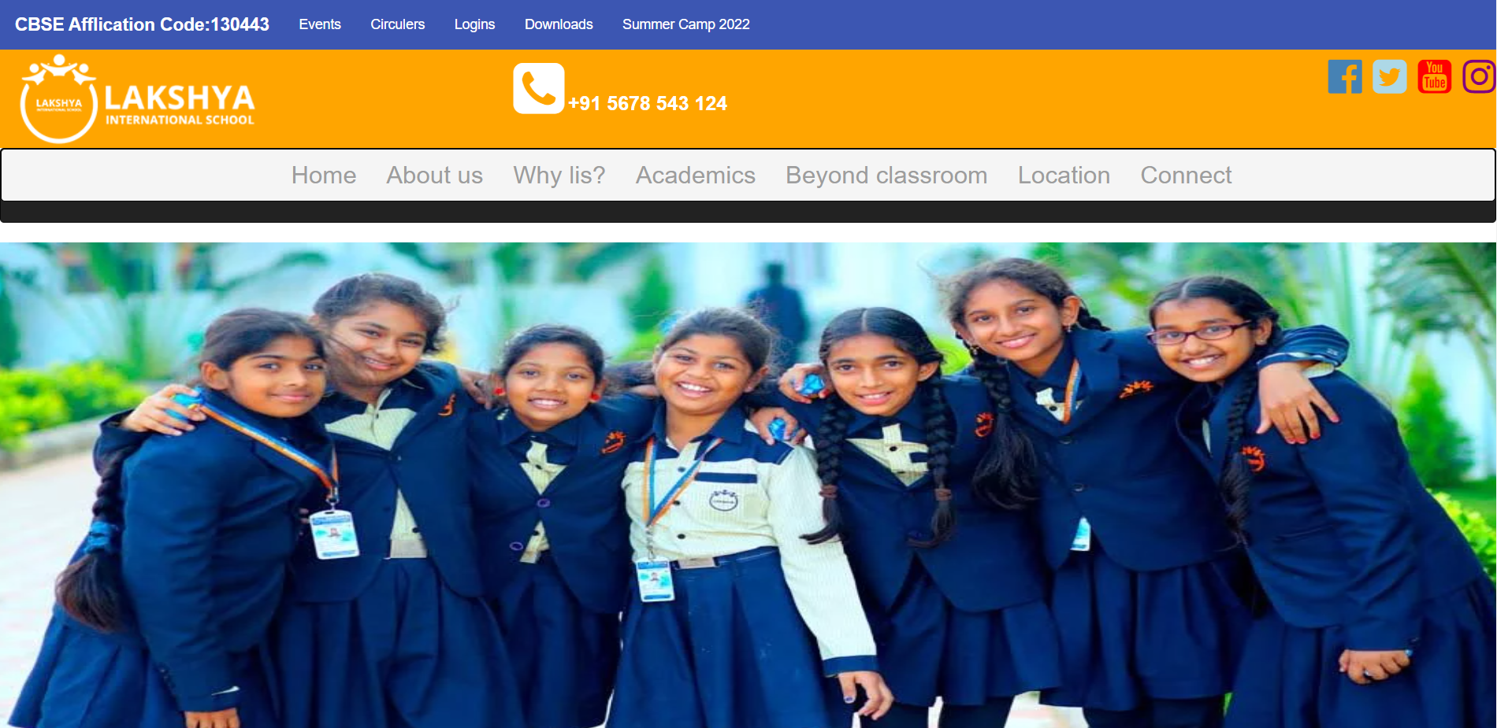

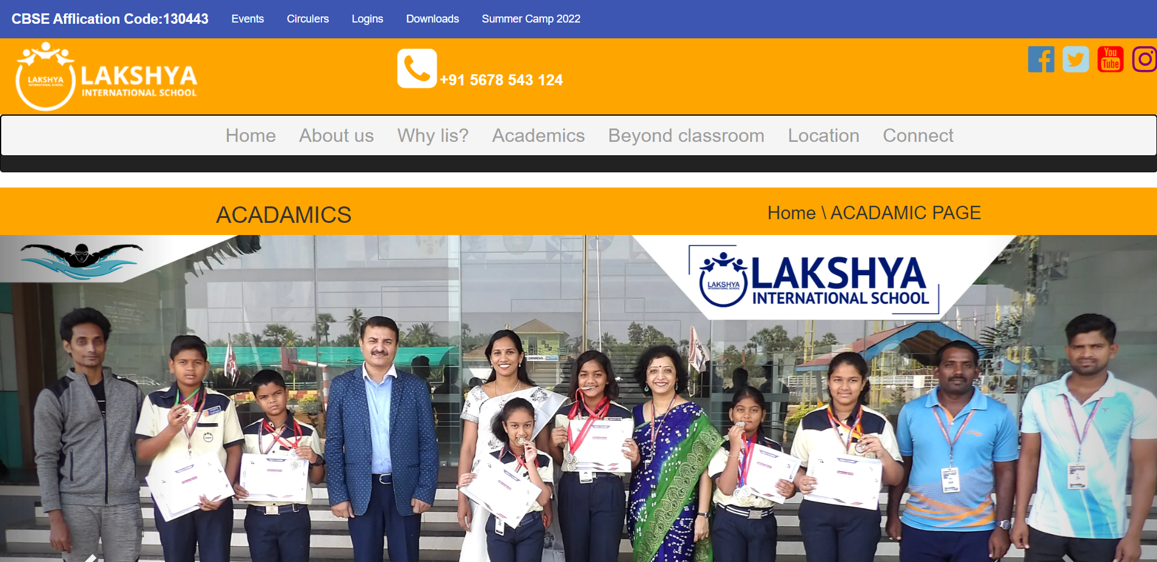

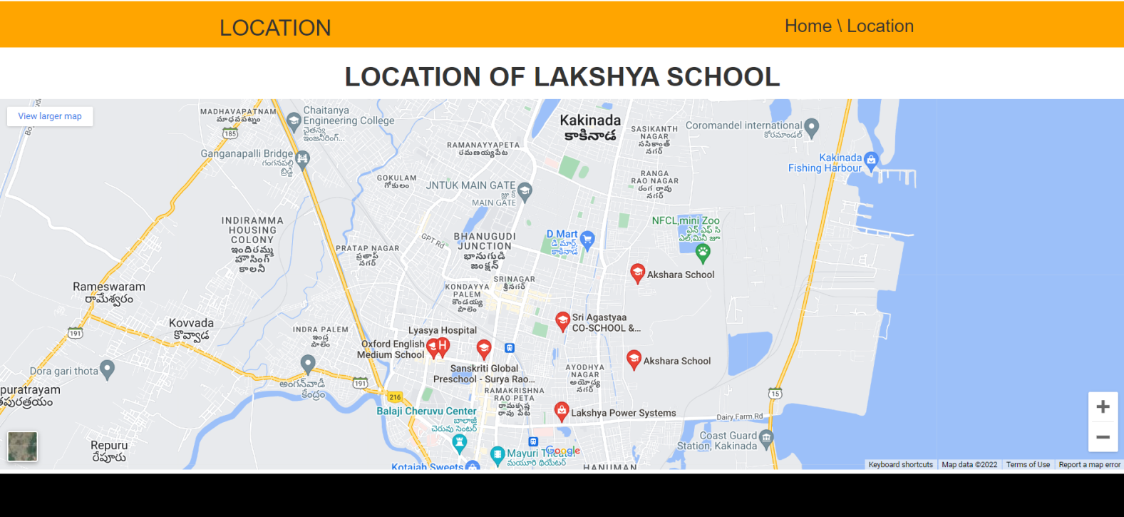

The another project that I had done on Full Stack development is LEARN TO DRIVE . In this website, I had mainly focused on HTML, CSS . It is type ofwebsite which helps us to learn and register in an academy of driving school and to get Licensed .

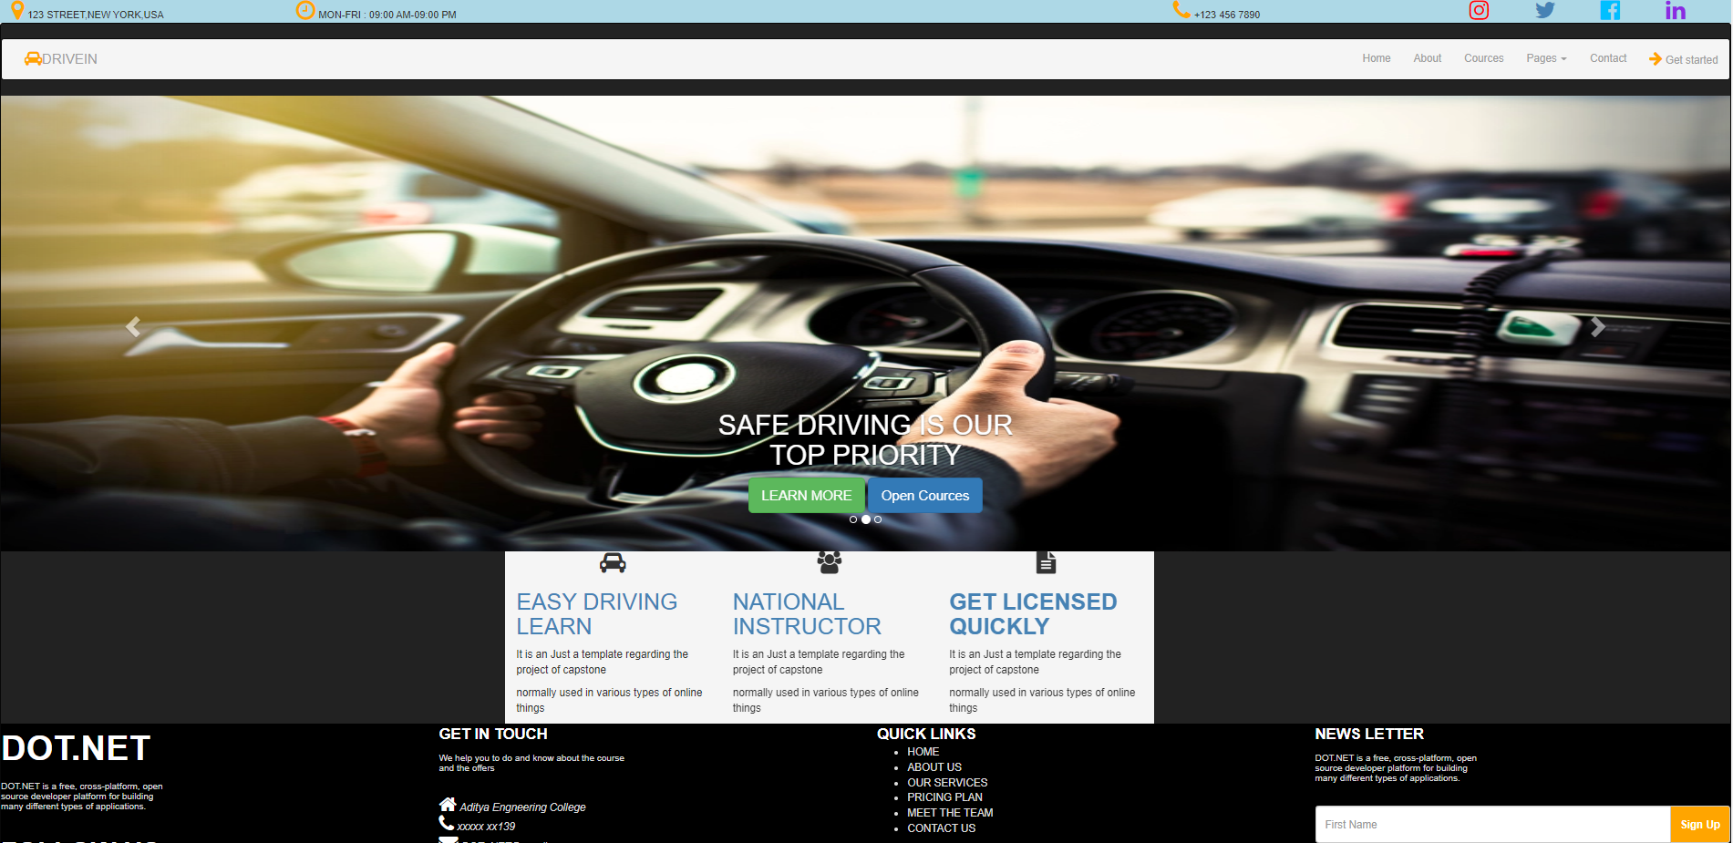 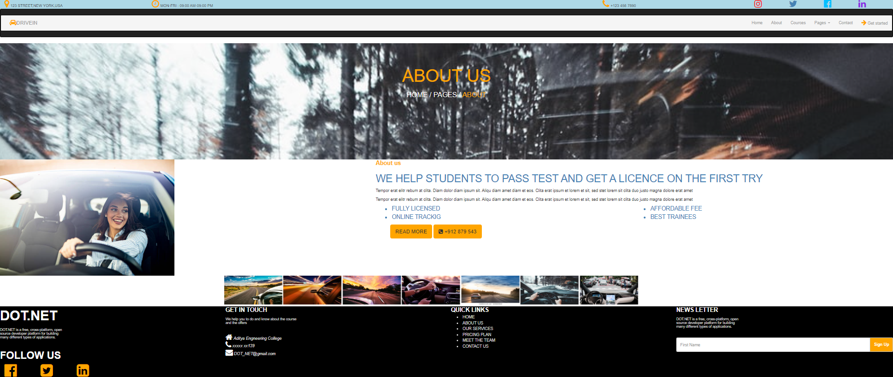

The Following are some of the tasks that I have performed during theTtraining Period that includes the Digital Resume, Attendance Portal etc.

